ITCS 6166/8166 – Computer Communications and Networks

Project - Distance Vector Routing Protocol

Ashwini Kadam (800967986)

Sanju Kurubara Budi Hall Hiriyanna Gowda (800953525)

**Routing:**

* Routing is the process of selecting paths in a network along which to send network traffic.
* Goals of routing are correctness, simplicity, Robustness, Stability, Fairness and Optimality.
* Routing Algorithms can be classified as Static or Dynamic Algorithm depending on how network router tables get updated according to link state change.

**Distance vector routing:**

* Distance vector routing is a simple distributed routing protocol.
* Distance vector routing allows routers to automatically discover the destinations reachable inside the network as well as the shortest path to reach each of these destinations.
* The shortest path is computed based on metrics or costs that are associated to each link.

**Project Design:**

Project design is based mainly on four classes.

1. RTableDetails

This is basic component of table. It consists of source, destination and cost of link from source to destination and next hop on the shortest path. An object of this class represents one entry for one router.

2. RouterTable

Each router will maintain routing table through which it calculates shortest path. In the event of link cost change or network topology change, router updates its table and informs its immediate neighbors.

RouterTable consists of objects of RTableDetails, one for each router.

This class also maintains list of immediate neighbors and next hops in shortest path. We also have Hash map of cost which represents router name and cost of shortest path.

3. RouterSender

This class sends out UDP Datagram packets every 15 seconds to all neighbors of router. Before sending the packet, each router checks if link cost has changed for any neighbors by re-loading the data from .dat file. If link cost has changed, routing table is updated.

4. RouterManager

This class contains main method. RouterManager creates socket for router and sends/receives information from other routers. When router socket is created, initial table is constructed for that router by reading data file. Then each router sends packet with latest routing information and also receives it from immediate neighbors after every 15 seconds. If received table has new or different link cost, then routing table may be updated depending on the cost change and new shortest route possible.

**Project Implementation:**

Each router acts as sender and receiver. As a sender, router will send its routing table in UDP packet. As a receiver, router receives packets from immediate neighbors. If link cost is changed or if network topology is changed, tables are updated.

If we have 'n' routers in network, we run 'n' instances of program. Each instance will read port number and router data file.

**Project Environment:**

This project has been implemented in Java. You need working java and jdk setup. We have also used NetBeans/Eclipse IDE for development. Program can be run using command prompt instances (one for each router).

**Project Input:**

For every router, we have one .dat file named after the router. This file contains entry for number of immediate neighbors followed by router names and cost to reach to that router

Example: a.dat

2

b 3.0

c 2.0

**Project output:**

Each router prints output on system console every 15 sec along with calculated cost to every destination and next hop on this path.

Example:

------------------output number 3-----------------------

shortest path a-a: the next hop is - and the cost is 0.0

shortest path a-b: the next hop is b and the cost is 3.0

shortest path a-c: the next hop is c and the cost is 2.0

**Screenshots**

**Router a:**

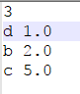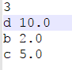

**(Before link cost change) (After link cost change)**

**Before Link cost change**

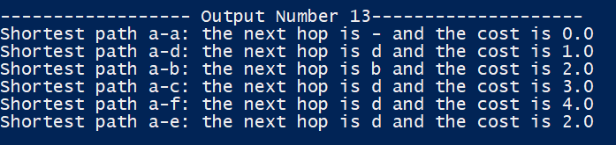

**After Link cost change**

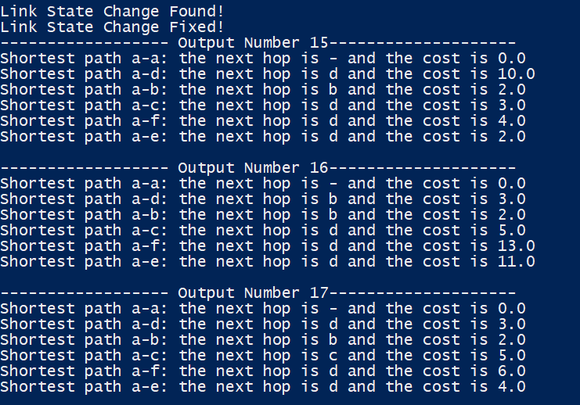

**Instructions to execute the code.**

Please check the attached Readme file.